It’s a Crash Test, Dummy Student Lab

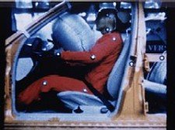

INTRODUCTION
In a real automobile safety restraint system, the air bag is a large plastic bag of about 65.0 L which fills with nitrogen as soon as a sensor tells it that the car’s forward momentum has been drastically lowered. The nitrogen is produced by the rapid decomposition of sodium azide (NaN₃), which produces nitrogen gas (N₂).
Purpose:
In this lab, we will create our own air bag technology utilizing sodium bicarbonate (baking soda) and acetic acid (vinegar). Your task is to find the correct amounts of sodium bicarbonate and acetic acid to use to create the right amount of gas (carbon dioxide) to fill the bag. If done correctly, your bag should fill up, but not pop open. There also should not be any sodium bicarbonate or acetic acid left in the bag.
Materials:
acetic acid sodium bicarbonate plastic bag tissue
graduated cylinder/pipette electronic balance
Procedure:
You will design a procedure to carry out this investigation and submit your calculations.
Volume of the baggy = 80 mL
T=26.6°C
P=101.6kPa

