We Scream For Ice Cream Answers
Ice cream is simply frozen cream to which fruits or flavourings have been added. Before electric refrigeration was invented, a mixture of ice and salt was used to achieve temperatures low enough to freeze cream. Just as we sprinkle salt on the roads to melt snow and ice, salt is mixed with ice to lower the melting point of ice. In addition, the melting of any solid requires that energy be absorbed from its surroundings. As a result, as the ice melts, energy from the cream mixture will be absorbed, causing it to freeze.
Purpose: To combine salt and ice to create very low temperature surroundings in order to make ice cream. To calculate the molar enthalpy of fusion (melting) for water (∆H_{fus}).
Procedure:
- Place ½ cup cream, 2 tbsp sugar, and ¼ tsp vanilla into the small bag and seal it.
- Place 2 cups of ice inside the large bag. Use the thermometer to measure the temperature of the ice. ______________ °C
- Add 1 tbsp of salt to the ice, and mix. Measure and record the temperature of the ice-salt mixture. _____________ °C
- Add a second tbsp of salt to the ice-salt mixture, and mix. Measure and record the temperature again. ____________ °C
- Place the sealed small bag inside the large bag. Seal the large bag securely.
- Shake the bags gently for about 10 min. Hold the bag only by the top corners when shaking. Avoid contact with the rest of the bag.
- When the cream mixture is frozen, open the bags. Be careful to keep the salt and ice out of the ice cream.
Analyze and Evaluate:
- What happened to the temperature of the ice after salt was added? The temperature of the ice decreased.
- What happened to the state of the ice after salt was added to it? Some of the ice change to liquid, but a slurry of ice/water mixture was formed.
- What was the purpose of adding salt to the ice in this recipe? The salt lowers the freezing point of ice (water).
- Salt is added to the ice and snow on the roads to keep the roads safe for driving. From what you have learned in this activity, why does spreading salt on roads in the winter improve road safety? Salt will lower the freezing point of water, so that ice doesn’t form and keeps it in liquid state. Liquid state is safer, as vehicle tires have more traction with the road when wet versus icy.
- What is the molar enthalpy of fusion (melting) for water (∆H_{fus})? 6 kJ/mol
Errors – slurry of ice/water
What specific heat capacity value do you use? What are some possibilities in the lab to solve this?
- Where does the energy required to melt the ice come from? The ice absorbs heat from its surroundings. What law does this follow? The second law of thermodynamics. Heat is transferred from the hotter object to the cooler object until they are the same temperature.
- Draw pictures to show the intermolecular forces present and indicate the type of intermolecular forces present.
  - Before the salt is added to the ice hydrogen bonding
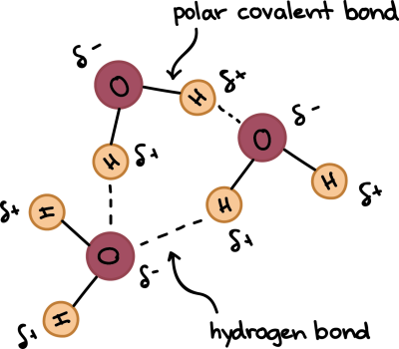
  - After the salt is added to the ice ion – dipole
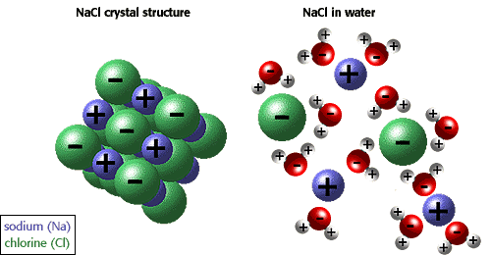
- Using your diagrams in question 7, explain how salt lowers the melting point of water. The salt (NaCl) dissolves nicely in water. It disrupts the intermolecular forces between the water molecules. The sodium ion is attracted to the partially negative end of the water molecule (O atom) and the chloride ion is attracted to the partially positive end of the water molecule (H atoms), interrupting the hydrogen bonding.

