# electron groups | Geometric arrangement of electron groups | VSEPR Notation | Molecular Shape
 | linear | AX₂ | Linear
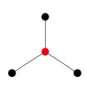 | trigonal planar | AX₃ | trigonal planar
 |  | AX₂E | bent
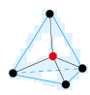 | tetrahedral | AX₄ | tetrahedral
 |  | AX₃E | trigonal pyramidal
 |  | AX₂E₂ | bent
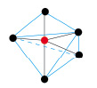 | trigonal bipyramidal | AX₅ | trigonal bipyramidal
 |  | AX₄E | seesaw
 |  | AX₃E₂ | t-shaped
 |  | AX₂E₃ | linear
 | octahedral | AX₆ | octahedral
 |  | AX₅E | square pyramidal
 |  | AX₄E₂ | square planar

