Worksheet: Safety Symbols

Hazardous Hausehold Product Symbols (HHPS) are warning symbols found on household products
Complete the following table and then think of one precaution you could take to keep yourself safe when using a product classified using the symbol.

Workplace Hazardous Materials Information System (WHMIS) symbols were developed to standardize the labeling of dangerous materials used in all workplaces, including schools. A new system was introduced in 2015.

Complete the following table, using the following website to find the name of the symbol, and then think of one precaution you could take to keep yourself safe when using a product classified using the symbol. http://www.ccohs.ca/products/publications/WHMISafterGHS.pdf pg 4
Symbol | Risks | One Precautions
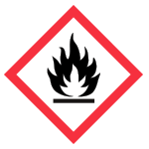
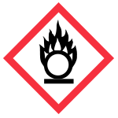
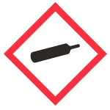
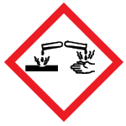
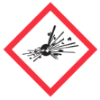
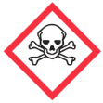
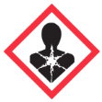
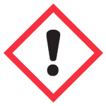

- Products with which WHMIS symbols should be stored separately? Why?

- We store tanks of oxygen gas and hydrogen has in the storage room at W-O. These gasses are under high pressure. Which WHMIS symbol would you expect to see on these tanks?

- If acid splashed and lands on your skin, you skin will get irritated, and it may burn. Which WHMIS symbol would you expect to see on bottles of acid?

Answer questions #1,2,3,6, pg 4 in your textbook.

