Worksheet: Safety Symbols
Safety symbols are used to identify dangers associated with products. There are two types of safety symbols, Hazardous Household Product Symbols (HHPS) and Workplace Hazardous Material Information System (WHMIS) symbols.

- Why do you think symbols are used (instead of words) to indicate the dangers associated with a product?
- Symbols are faster to recognize in an emergency
- All languages understand pictures
- Some people can’t read
Hazardous Household Product Symbols (HHPS) are warning symbols found on household products.

Symbol | Name | Risks | Precautions
 | Explosive | This container can explode if it’s heated or punctured. Flying pieces of metal or plastic can cause serious injuries, especially to the eyes.  Example: spray paint in an aerosol container | Do not heat or puncture. Store on a low shelf.
 | Corrosive | This product will burn skin or eyes on contact, or throat and stomach if swallowed.  Example: toilet bowl cleaner, oven cleaner | Wear gloves, goggles and read the label for additional information
 | Flammable | This product, or its fumes, will catch fire easily if it’s near heat, flames or sparks.  Example: gasoline | Keep away from heat or flame. Store away from the explosives.
 | Poisonous | Licking, eating, drinking or sometimes smelling, this product will cause illness or death.  Example: windshield washer fluid, antifreeze | Do not drink, smell, or taste. Read the label for additional precautions.

These symbols are made up of a picture and a frame. The picture tells you the type of danger. The frame tells you if it is the chemical inside the container that is hazardous or if it is the container that is hazardous.
Shape | Meaning
Triangle (inverted) | Container is dangerous
Octagon | Contents are dangerous (inside)

2. Workplace Hazardous Materials Information System (WHMIS) symbols were developed to standardize the labeling of dangerous materials used in all workplaces, including schools. A new system was introduced in 2015.

Symbol | Risks | Precautions: Read the Safety Data Sheet (SDS) and use appropriate Personal Protective Equipment (PPE) before use
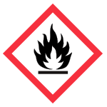 | Flammable | Keep away from heat/flame. Store away from explosives, oxidizing material and compressed gas.
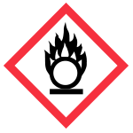 | Oxidizing Material | Do not store with flammable items.
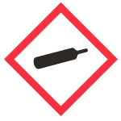 | Gas Under Pressure: could explode if punctured, dropped or heated | Handle with care, store properly
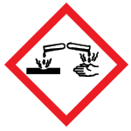 | Corrosion: Serious eye damage, corrosive to skin and to metals
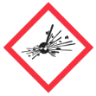 | Explosive material | Handle with care and store away from flammable material, oxidizers or compressed gas
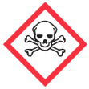 | Immediately toxic, can cause death
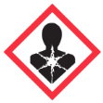 | Health Hazard: carcinogens and mutagens
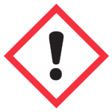 | Irritation (skin or eyes), organ toxicity
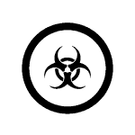 | Biohazardous and infectious material
- Products with which WHMIS symbols should be stored separately? Why?

- We store tanks of oxygen gas and hydrogen gas in the storage room at W-O. These gasses are under high pressure. Which WHMIS symbol would you expect to see on these tanks?

- If acid splashed and lands on your skin, you skin will get irritated, and it may burn. Which WHMIS symbol would you expect to see on bottles of acid?

