Unit 5: Gases Review

Multiple Choice: Identify the letter of the choice that best completes the statement or answers the question.

1. Which of the following statements are true?
(i) As temperature goes down, molecules move more rapidly.
(ii) If the volume is constant, an increase in pressure may be a result of an increase in the number of molecules in the container.
(iii) The molecules of a gas are in constant, random, and nonlinear motion.
(iv) The volume of a given mass of gas varies directly with its absolute temperature when the pressure remains constant.
a. | (i) and (ii) | d. | (i) and (iii)
b. | (ii) and (iii) | e. | (ii) and (iv)
c. | (iii) and (iv)

2. How many molecules of an ideal gas are contained in 8.2 L at –73ºC and 50.6 kPa?
a. | 0.25 | d. | 7.5 x 10²³
b. | 1.5 x 10²³ | e. | 4.2 x 10^{–25}
c. | –4.1 x 10²³

3. N₂ has a volume of 5.50 L at a pressure of 199.99 kPa and at a temperature of 25ºC. What must the temperature be if the new volume is 10.0 L, but is a constant pressure?
a. | 370ºC | d. | 32ºC
b. | 269ºC | e. | –109ºC
c. | 154ºC

4. The number of grams of helium in a balloon at a pressure of 99.8 kPa, a temperature of 301 K, and a volume of 0.785 L would be
a. | 0.125 g | d. | 0.278 g
b. | 814 g | e. | none of the above
c. | 337 g

5. Sorry remove this question as well.

Problems:
6. What is the initial pressure of a gas if it occupied a volume of 375 mL, but now occupies a volume of 1.25 L at a pressure of 95.5 kPa. Assume that the temperature remains constant throughout the process.

7. Determine the volume occupied by 3.45 g of carbon dioxide gas at STP.

8. A sample of a gas occupies 15.5 L at 245ºC and under a pressure of 95.5 kPa. At what temperature, in degrees Celsius, will the gas occupy a volume of 20.5 L if the pressure is increased to 107 kPa?

9. What pressure, in kPa, is exerted by 75.0 g of xenon gas in a 2.25-L flask at 27ºC?

10. What mass of CO₂ can be produced at a temperature of 1500ºC and an atmospheric pressure of 92.5 kPa, if 15.5 L of C₂H₂ gas is burned at STP conditions?
2C₂H_{2 (g)} + 5O_{2 (g)} 2H₂O_{(g)} + 4CO_{2 (g)}
Unit 5: Gases Review Answer Section

MULTIPLE CHOICE

1.E 2.B 3.B 4.A 5.B

PROBLEM
6. V₁ = 375 mL P₂ = 95.5 kPa V₂ = 1.25 L P₁ = ?
Convert mL to L for V₁: 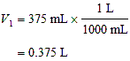
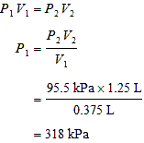
The pressure of the gas was 318 kPa.

7. m = 3.45 g T = 273 K P = 101.325 kPa R = 8.31 kPa L/mol K V = ?
Convert mass to moles of CO₂: 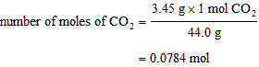
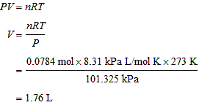
The volume occupied by the CO₂ is 1.76 L.

8.
P₁ | V₁ | T₁ | P₂ | V₂ | T₂
95.5 kPa | 15.5 L | 245ºC + 273 = 518 K | 107 kPa | 20.5 L | ?

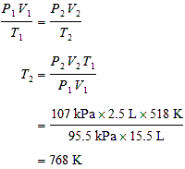
The new temperature will be 495ºC.
9.
P | V | n | R | T
? | 2.25 L | ? | 8.31 kPa L/mol K | 27ºC + 273 = 300 K

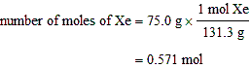

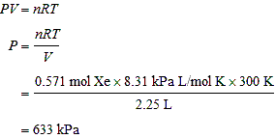
The pressure in the flask will be 633 kPa.

10. P = 101.325 kPa
T = 273 K
V = 15.5 L
R = 8.31 kPa L/mol K
n = ?

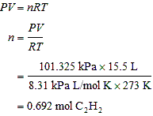

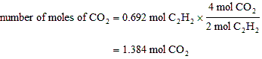

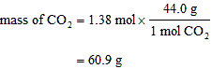
The mass of CO₂ will be 60.9 g, regardless of the temperature or pressure.

