Unit 4: Solutions and Solubility Review

Multiple Choice: Identify the letter of the choice that best completes the statement or answers the question.

1. Which of the following has a concentration of 2 mol/L?
a. | 2 mol/1 L | d. | 2 mol/2 L
b. | 2 mol/1000 mL | e. | a, b, and c only
c. | 5 mol/2.5 L

2. A solution that contains the maximum quantity of a solute at a specific temperature is
a. | saturated | d. | dissolved
b. | unsaturated | e. | none of the above
c. | supersaturated

3. As the temperature of a solution increases, the solubility of salts ____ and the solubility of gases _____.
a. | doesn't change, doesn't change | d. | decreases, decreases
b. | increases, decreases | e. | decreases, increases
c. | increases, increases

4. Which of the following combinations of aqueous solutions would produce a precipitate?
a. | ammonium sulphide and zinc bromide
b. | potassium chloride and sodium nitrate
c. | iron(III) nitrate and potassium hydroxide
d. | all of the above
e. | a and c only

5. A compound that ionizes in water to form hydroxide ions is
a. | an acid | d. | both a and b
b. | a salt | e. | both b and c
c. | a base

6. According to its Arrhenius definition, a weak base
a. | partially reacts with water to form OH–_{(aq)}
b. | fully reacts with water to form OH–_{(aq)}
c. | completely dissociates to form OH–_{(aq)}
d. | has very high pH
e. | is an ionic hydroxide

Problem
7. T.S.P. is an all purpose cleaner that can be used to clean driveways. What volume of solution would you get if you dissolved 150.0 g of sodium phosphate with water to produce a 0.23 mol/L solution?
8. What volume of a 17.4 mol/L acetic acid stock solution is required to make 2.0 L of a 1.5 mol/L acetic acid solution?
9. Standard solutions of sodium oxalate, Na₂C₂O_{4(aq)}, are required for certain types of chemical analyses. If 8.5 g of sodium oxalate is dissolved in 500 mL of distilled water, calculate the concentration of the sodium ion and the concentration of the oxalate ion dissolved in this solution.
10. A student mixed 100.0 mL of a 0.100 mol/L solution of barium chloride with 100.0 mL of a 0.100 mol/L solution of iron(III) sulphate. The barium sulphate precipitate was filtered, dried, and was measured to have a mass of 2.0 g. Calculate the % yield of the barium sulphate.
11. A swimming pool has a pH of 7.5. Calculate the hydrogen ion concentration in the pool.
12. A titration was performed on a 10.00-mL sample of water taken from an acidic lake. If it took 8.66 mL of 0.0512 mol/L NaOH_{(aq)} to neutralize the sulfuric acid in the lake water sample, calculate the concentration of the sulfuric acid. What is the pH of this lake water?
13. The hydrogen ion concentration in beer is 3.12 x 10^{–5} mol/L. Calculate the pH of beer.
Unit 4: Solutions and Solubility Review Answer Section

MULTIPLE CHOICE

1.E 2.A 3.B 4.E 5.C 6.A

PROBLEM
7. 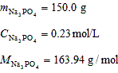 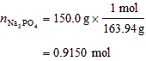 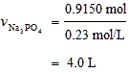
The volume of the solution will be 4.0 L.

8. 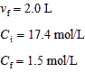 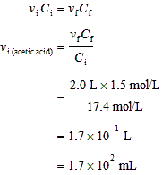
The volume of the stock acetic solution needed is 1.7 x 10² mL.

9. 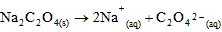
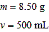
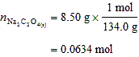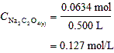
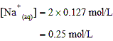
The sodium ion concentration is 0.25 mol/L.

The oxalate ion concentration is 0.13 mol/L.

10. 3BaCl_{2(aq)} + Fe₂(SO₄)_{3(aq)} 3BaSO_{4(s)} + 2FeCl_{3(aq)}
100.0 mL | 100.0 mL | m
0.100 mol/L | 0.100 mol/L

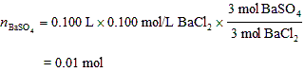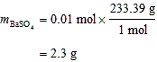
The theoretical mass of barium sulfate is 2.3 g.

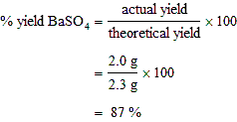
The % yield of the barium sulfate precipitate was 87%.

11. 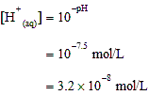
The hydrogen ion concentration of the swimming pool is 3.2 x 10^{–8} mol/L.

12. H₂SO_{4(aq)} + 2NaOH_{(aq)} Na₂SO_{4(aq)} + 2H₂O_{(l)}
10.00 mL | 8.66 mL
C | 0.00512 mol/L

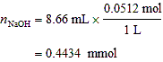

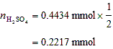

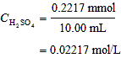
The sulfuric acid concentration in the lake is 0.0222 mol/L.
H₂SO₄ (aq) 2 H+ (aq) + SO₄²⁻ (aq)
[H+] = 2 (0.02217 mol/L)
pH = -log[H+]
= -log (2x0.02217)
= 1.35

The pH of the lake water is 1.35.

13. 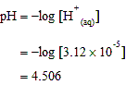
The pH of beer is 4.506.

