Unit 3: Quantities in Chemical Reactions Review

Multiple Choice: Identify the letter of the choice that best completes the statement or answers the question.

1. Chlorine has two naturally occurring isotopes, namely and . The composition of chlorine is 25.0% and 75.0% . The average atomic mass of chlorine is
a. | 36.5 u | d. | 45.5 u
b. | 35.5 u | e. | 32.0 u
c. | 34.6 u

2. A mass of 2.20 kg of sodium phosphate is converted into the following number of moles
a. | 7.45 mol | d. | 13.4 mol
b. | 74.5 mol | e. | 45.8 mol
c. | 1.34 x 10^{–2} mol

3. The number of molecules found in 0.87 mol of carbon monoxide is
a. | 4.1 x 10²³ molecules | d. | 9.3 x 10²⁴ molecules
b. | 5.2 x 10²³ molecules | e. | 1.5 x 10²⁵ molecules
c. | 2.9 x 10²⁴ molecules

4. A 100.0-g sample of a compound is composed of 16.3 g of carbon, 32.1 g of chlorine, and
51.6 g of fluorine. The empirical formula of the compound is
a. | CClF | d. | C₃Cl₂F₆
b. | CClF₃ | e. | C₉Cl₆F₁₈
c. | C₂Cl₂F₆

5. When copper is combined with a solution of silver nitrate, the resulting products are copper(II) nitrate and silver. The balanced equation for this reaction is
a. | Cu + 2AgNO₃ Cu(NO₃)₂ + 2Ag
b. | 3Cu + 3AgNO₃ 3Cu(NO₃)₂ + 3Ag
c. | 2Cu + 2AgNO₃ 2CuNO₃ + 2Ag
d. | Cu + 2AgNO₃ CuNO₃ + 2Ag
e. | 2Cu + 2AgNO₃ 2Cu(NO₃)₂ + 2Ag

Problem

6. Magnesium hydroxide, Mg(OH)₂, can be commonly found in antacids. Calculate the percentage composition, by mass, of each element in magnesium hydroxide.

7. A compound was found to contain 10.06% C, 89.10% Cl, and 0.84% H, by mass. If the molar mass of the compound is 119.6 g/mol, calculate its molecular formula.

8. Consider the following reaction: AlCl_{3(aq)} + 4NaOH_{(aq)} NaAlO_{2(aq)} + 3NaCl_{(aq)} + 2H₂O_{(l)}
How many grams of sodium chloride can be obtained from 4.46 g of AlCl₃?

9. Sodium chloride is produced when sodium metal combines with chlorine gas as shown in the following balanced equation: 2 Na + Cl₂ 2 NaCl
In an experiment, 36.9 g of sodium chloride is produced when 15.9 g of Na and 27.4 g of chlorine are combined. Determine the percentage yield of the product.
Unit #3: Quantities in Chemical Reactions Review Answer Section

MULTIPLE CHOICE

1.B 2.D 3.B 4.D 5.A

PROBLEM

6. m_{Mg} = 24.30 u x 1 atoms = 24.30 u
m_{O} = 16.00 u x 2 atoms = 32.00 u
m_{H} = 1.01 u x 2 atoms = 2.02 u
m_{total} = 58.32 u

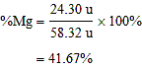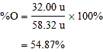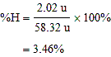
The percentage composition, by mass, of Mg(OH)₂ is 41.67% magnesium, 54.87% oxygen, and 3.46% hydrogen.

7.
m_{C} = 10.06%  100.0 g C = 10.06 g |  | M_{C} = 12.01 g/mol
m_{Cl} = 89.10%  100.0 g Cl = 89.10 g |  | M_{Cl} = 35.50 g/mol
m_{H} = 0.84%  100.0 g H = 0.84 g |  | M_{H} = 1.01 g/mol

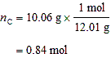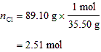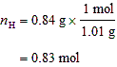

The molar ratio for C:Cl:H is 0.84:2.51:0.83. Dividing by 0.83 to obtain the lowest ratio, we obtain the molar ratio of 1:3:1. The empirical formula of the compound is CCl₃H.

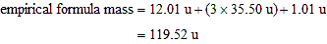

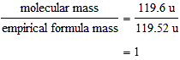
The molecular formula of the compound is CCl₃H.

8.
mole ratio: | AlCl₃:NaCl = 1:3

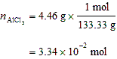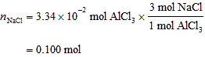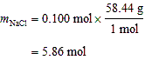
The mass of sodium chloride that can be obtained is 5.86 g.

9. We can determine the number of moles of chlorine needed to react completely with 15.9 g of Na.
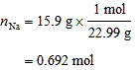

mole ratio: | Na:Cl₂ = 2:1

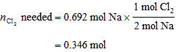

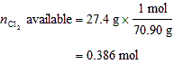
More chlorine is available than is required, therefore, chlorine is in excess. The sodium is the limiting reagent.

mole ratio: | Na:NaCl = 1:1

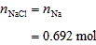

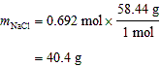
The theoretical yield of the NaCl is 40.4 g.

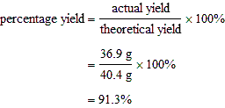
The percentage yield is 91.3%.

