Station 1:
What are the FIVE major factors that affect reaction rate?

Station 2:
Why would a mixture of gases react faster when the volume they occupy is decreased?
Why would iron filings rust faster than an iron nail?
What is the effect of a catalyst on the required energy to achieve effective collisions?

Station 3:
- Classify these reactions as exothermic or endothermic:
  - energy + SO₂ (g) → S (g) + O₂ (g)
  - C₈H₁₈ (g) + O₂ (g) → CO₂ (g) + H₂O (g) + energy
  - energy + P₄O₁₀ (s) → P₄ (s) + 5 O₂ (g)
  - Mg (s) + H₂SO₄ (aq) → MgSO₄ (aq) + H₂ (g) + energy

Station 4:
- Consider the combustion of nitrogen monoxide:
NO(g) + ½ O₂(g) NO₂ (g) ΔH = -56.5 kJ

How much heat would be released by the combustion of 65 g of O₂ (g)?

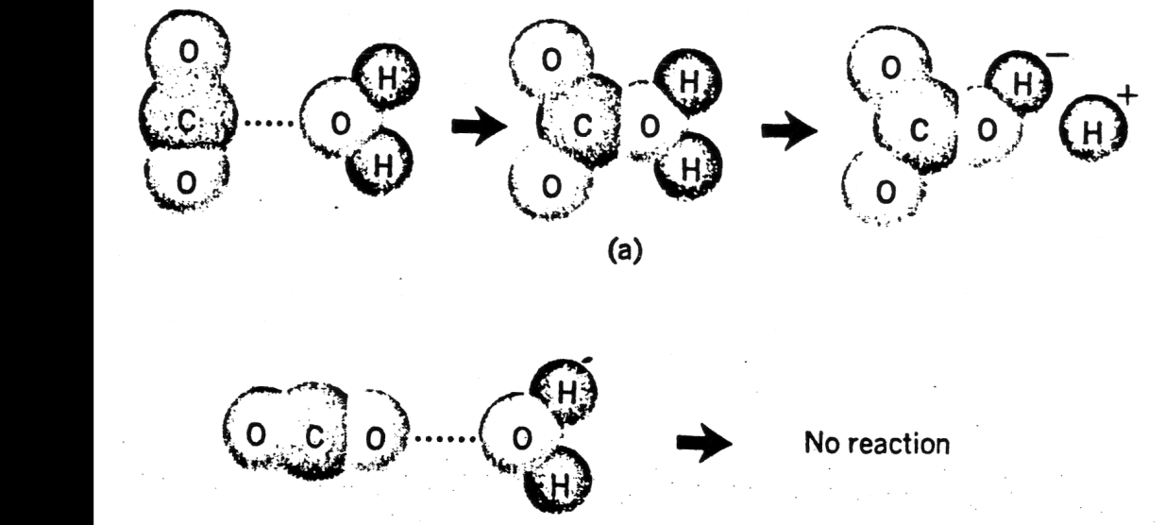
Station 5: In the reaction below explain what is happening. In A) a rxn happens but B) no rxn happens. Why could this be? A
What is this (labelled a in the picture)
B
Station 6:
Example: NH₄⁺ _{(aq)} + NO₂⁻ _{(aq)} N₂ _{(g)} + 2 H₂O _{(l)}

Suppose r = k[NH₄⁺] [NO₂⁻]
The rate of this reaction is 5.4 x 10⁻⁷ mol/L∙s when [ NH₄⁺]= 0.0100 mol/L and
[NO₂⁻]=0.200 mol/L.

Calculate the new rate of the reaction when [ NH₄⁺]= 0.100 mol/L and
[NO₂⁻]=0.255 mol/L.

Station 7:
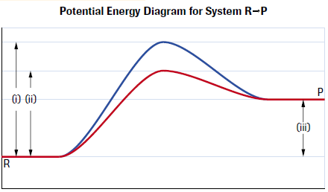
- Use the potential energy diagram shown below to answer the following:
  - Label the axis.
  - What does each curve represent?
  - What type of reaction is occurring in terms of energy flow to or from the surroundings?
  - What does each number

Station 8:
A proposed mechanism for the reaction between iodine chloride gas and hydrogen gas is shown below.
ICl _{(g)} + H₂ _{(g)} → HI _{(g)} + HCl _{(g)} (slow)
HI _{(g)} + ICl _{(g)} → HCl _{(g)} + I_{2 (g)} (fast)

a) Write the balanced equation for the overall reaction.
b) What are the reactions intermediates (if any)?
c) The rate law equation was determined experimentally to be
r = k[ICl][H₂]. Does the proposed mechanism above agree with the experimental results? If it does not agree, explain why not.
Station 9:
Consider the following reaction that occurs in the atmosphere on a smoggy day:
NO _{(g)} + O_{3 (g)} → NO_{2 (g)} + O_{2 (g)} r = k[NO]

Which of the following mechanisms is consistent with this rate law? Explain.
a) NO + O₃ → NO₂ + O₂ (slow)

b) NO → N + O (slow)
N + O₃ → NO₂ + O (fast)
O + O → O₂ (fast)

NO + O₃ → NO₂ + O₂ (overall)

c) O₃ → O₂ + O (slow)
O + NO → NO₂ (fast)

NO + O₃ → NO₂ + O₂ (overall)

Station 10:

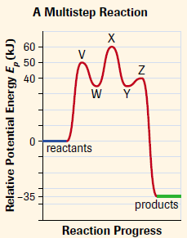
Use the multi-step reaction shown to the right to answer the following:
  - What is the overall activation energy for the reaction?
  - What is the reaction enthalpy (ΔH) for the reaction?
  - What is the rate-determining step for the reaction?
  - Is the reaction exothermic or endothermic?
  - Which letters represent activated complexes?
  - Which letters represent reaction intermediates?
Station 11:

The activation energy of a forward and reverse reaction are as follows:

i) C₂H₄ (g) + H₂ (g) C₂H₆ (g) E_{a} = 180 kJ/mol
ii) C₂H₆ (g) C₂H₄ (g) + H₂ (g) E_{a} = 317 kJ/mol

a) Draw a potential energy diagram for this reversible reaction.
b) Calculate the enthalpy change (∆H) for each reaction.

