SCH 3UI: Building Molecular Models Assignment
- Complete the first table. There is a spot for rough work and then for you to clean up the structure.
- Use the model kit to check your answers and to confirm the shape of the molecule. You will need 4-short, 3-long (for double and triple bonds), 2 black, 4 green, 4 white, 2 red, 1 blue. You can put the pieces into a ziplock bag to take back to your seat. You now should have the second table filled out.
- Answer question 3.
- Complete question 4 entirely for one molecule at a time.
Example for question 4:
HBr (chemical formula)
linear (shape)
(Lewis structure with shape and bond and overall molecular dipole.)
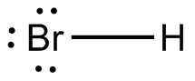

Bond is polar, molecule is polar.
1 bonding pair, 3 lone pairs of electrons

