Worksheet: Safety Symbols Answer Key

Hazardous Household Product Symbols (HHPS) are warning symbols found on household products
Complete the following table and then think of one precaution you could take to keep yourself safe when using a product classified using the symbol.

The container itself is dangerous | The contents inside the container are dangerous | Corrosive  Risk: This product will burn skin or eyes on contact, or throat and stomach if swallowed  Precaution: Use gloves and eye protection when using. Be sure to read all safety information prior to using | Explosive  Risk: This container can explode if it’s heated or punctured. Flying pieces of metal or plastic can cause serious injuries, especially to the eyes.  Precaution: Keep on a low shelf, do not store with flammable products, do not drop or puncture | Flammable  Risk: This product, or its fumes, will catch fire easily if it’s near heat, flames or sparks.  Precaution: Store in proper container. Do not store near explosive materials.  Keep away from heat | Poisonous  Risk: Licking, eating, drinking or sometimes smelling, this product will cause illness or death.  Precaution: Do not drink, smell or inhale product. Use proper safety equipment when dealing with it. If inhaled called the poison control number and seek medical assistance immediately.
Workplace Hazardous Materials Information System (WHMIS) symbols were developed to standardize the labeling of dangerous materials used in all workplaces, including schools. A new system was introduced in 2015.
Complete the following table, using the following website to find the name of the symbol, and then think of one precaution you could take to keep yourself safe when using a product classified using the symbol. http://www.ccohs.ca/products/publications/WHMISafterGHS.pdf pg 4
Symbol | Risks | One Precaution : Read the Safety Data Sheet (SDS) and use appropriate personal protective equipment
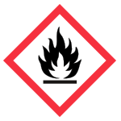 | Flammable – Fire hazards | Store safely and keep separate from oxidizing materials, compressed gas and explosive materials
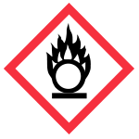 | Oxidizing solids, liquids and gases -Oxidizer, will cause materials to go up in flames | Should not be stored with flammable materials, should be kept away from compressed gases
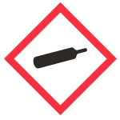 | Gas Under Pressure  Compressed gas, could explode if punctured or dropped | Handle with care, store properly
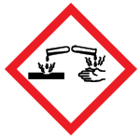 | Corrosion  Serious Eye Damage, Skin Corrosion, Corrosive to Metals
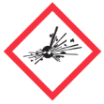 | Exploding bomb  Explosive, self-reacting, organic peroxides | Handle with care, do not store with flammable materials, oxidizers or compressed gas
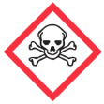 | Skull and Crossbones  Acute toxicity, can cause death or toxicity with short exposure to small amounts.
 | Health Hazard  May cause or suspected of causing serious health effects i.e., carcinogens, mutagens | Be sure to be informed prior to using, proper training
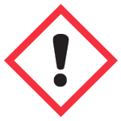 | Exclamation Mark  Irritation (skin or eyes), skin sensitization, acute toxicity (harmful), specific organ toxicity  Hazardous to the ozone layer (not required by WHMIS)
Biohazardous
Biohazardous infectious material

- Products with which WHMIS symbols should be stored separately? Why?

Oxidizing and flammable – oxidizers can feed a fire

- We store tanks of oxygen and hydrogen gas in the storage room at W-O. These gasses are under high pressure. Which WHMIS symbol would you expect to see on these tanks?
Compressed gas

- If acid splashed and lands on your skin, you skin will get irritated, and it may burn. Which WHMIS symbol would you expect to see on bottles of acid?
Corrosive

Answer questions #1,2,3,6, pg 4 in your textbook.

