Lab Activity: Measuring The Volume of Liquids Using a Graduated Cylinder
- Video: “How to Read a Graduated Cylinder” (http://www.youtube.com/watch?v=73Tl3aL2i1Y).
State three things you need to do in order to correctly read the volume of liquid in a graduated cylinder.

- Define the term meniscus; include a drawing to help illustrate your definition.
Meniscus: Drawing:

- Each graduated cylinder is different so it is important to look closely at the scale to make sure you know the value of each tick mark. What is the volume of liquid in each of the following graduated cylinders?
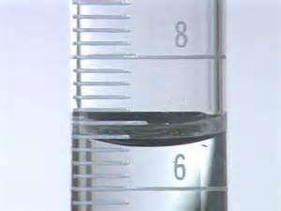 | 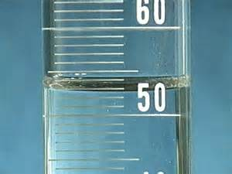 | 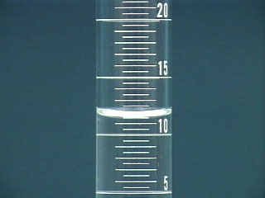

- Record the volume of liquid in each of the three graduated cylinders in the lab. Make sure to include units.
A. | B. | C.

